环保服务
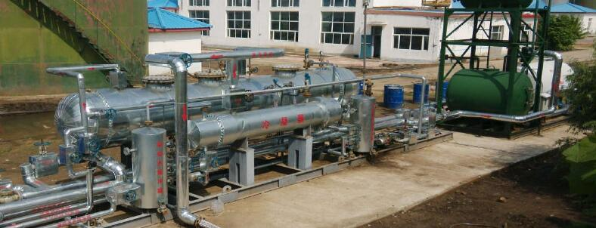
高原石油工程能够为顾客提供全过程系统服务，包括污水处理药剂生产开发和优选,提供污水处理方案，技术研发，水处理工程项目的咨询、工程设计、供货与施工，环保设备研制与生产，工程项目的投资，EPC总承包，水处理工厂的调试、问题诊断及运营管理等业务。多年以来，具有丰富的生产和服务经验。
可以承接大型项目调研、环境监测、化学方案设计、水处理用化学品研发、现场技术服务等业务

Environmental protection service
Highland services has now become one of the leading companies in the Chinese oil & gas environmental industry, being proud of providing our clients with whole-chain services, including water treatment chemical addictives optimization and supply, providing water treatment scheme, technical consulting, engineering design and construction, procurement, project EPC, BOT/BOO investment, environmental equipment manufacturing and installation, wastewater treatment plant debugging, problem diagnosis and operation management services, etc.

Our company capable of undertaking different businesses independently, such as large project research, environmental monitoring, chemical scheme design, targeted water treatment agent research and on-site technical services, etc.

水处理(环保服务下的分项)

针对国内外油田、页岩气污水、压裂返排液、市政污水以及工业废水等不同水质，公司已研发出水处理剂方案共计四大类十余种产品。

水处理实验室配备火焰和石墨炉原子吸收分光光度仪、傅立叶变换红外光谱仪、激光粒度分析仪、高压反应器、菌落计数器、自动平衡高速离心机。实验室配备综合分析室、综合实验室、生化室、色谱室、水处理等特殊实验室。可承接大型项目研究、环境监测、化工设计、化学研究开发及水处理、现场技术服务等服务。

Water treatment

We has developed targeted water treatment agent solutions for various water quality from different oilfields both at home and abroad, including more than 4 categories of products.

The waste water treatment laboratory is equipped with flame and graphite furnace atomic absorption spectrophotometers, Fourier transform infrared spectrometers, laser particle size analyzers, high-pressure reactors, colony counters, and automatic balance high-speed centrifuges. Laboratory, comprehensive analysis room, synthesis laboratory, biochemical room, chromatography room and water treatment and other special laboratories. Can undertake large-scale project research, environmental monitoring, chemical design, chemical research and development of water treatment, on-site technical services and other services.

天然气发电
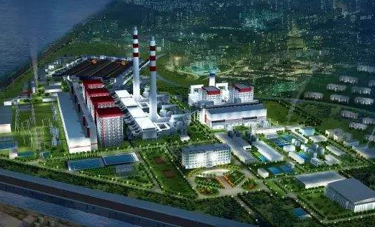
公司目前从事燃气发电产品及节能石油机械的研发、制造及相关运行服务, 产品拥有完全自主知识产权,对中国市场拥有更好的适应性,开创并推动了 中国燃气发电产业的发展。产品目前已应用于瓦斯、沼气、炼化尾气、油母 页岩气、发生炉燃气、天然气等几乎所有可燃气体领域,利用自主研发的产 品和技术把各项废弃可燃气体收集起来用于发电,达到节能减排、变废为宝、 化害为利的目标,不仅创造了良好的经济效益,更创造了可观的环保、安全 和社会效益,得到了社会各界和国外用户的高度认可。
Gas generation
The company mainly engaged in the manufacture, development and related operation service of gas power generation products and petroleum machinery. The products has completely independent intellectual property rights, has good market responds in China. With independent developed products and technology, we could collect and use all kinds of waste combustible gas for power generation, the gas include but not limited to coal mine gas, biogas, refinery gas, oil-shale gas, furnace gas and natural gas. Achieving the target of energy conservation, emissions reduction, waste to wealth, harm to good. The products and technology does not only create good economic benefit, but also creates good environmental protection, safety, and social benefits, wins a high admiration and is widely trusted by customers at home and abroad.

